**UNIVERSITI MALAYSIA TERENGGANU**



**CSM3103 FRONT-END PROGRAMMING**

**BACHELOR OF COMPUTER SCIENCE (MOBILE COMPUTING) WITH HONORS**

**LAB 1-BASIC OF BOOTSTRAPS**

**SEMESTER II 2023/2024**



**Prepared for:**

DR RABIEI BIN MAMAT

**Prepared by:**

MUHAMMAD IZZUL WAFIY BIN IZAM (S65466)

Task 1

Task 2

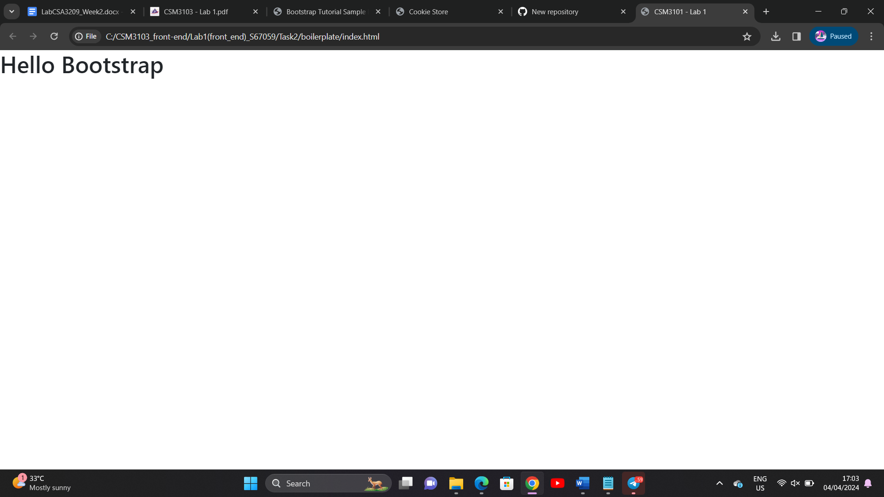

Task 3

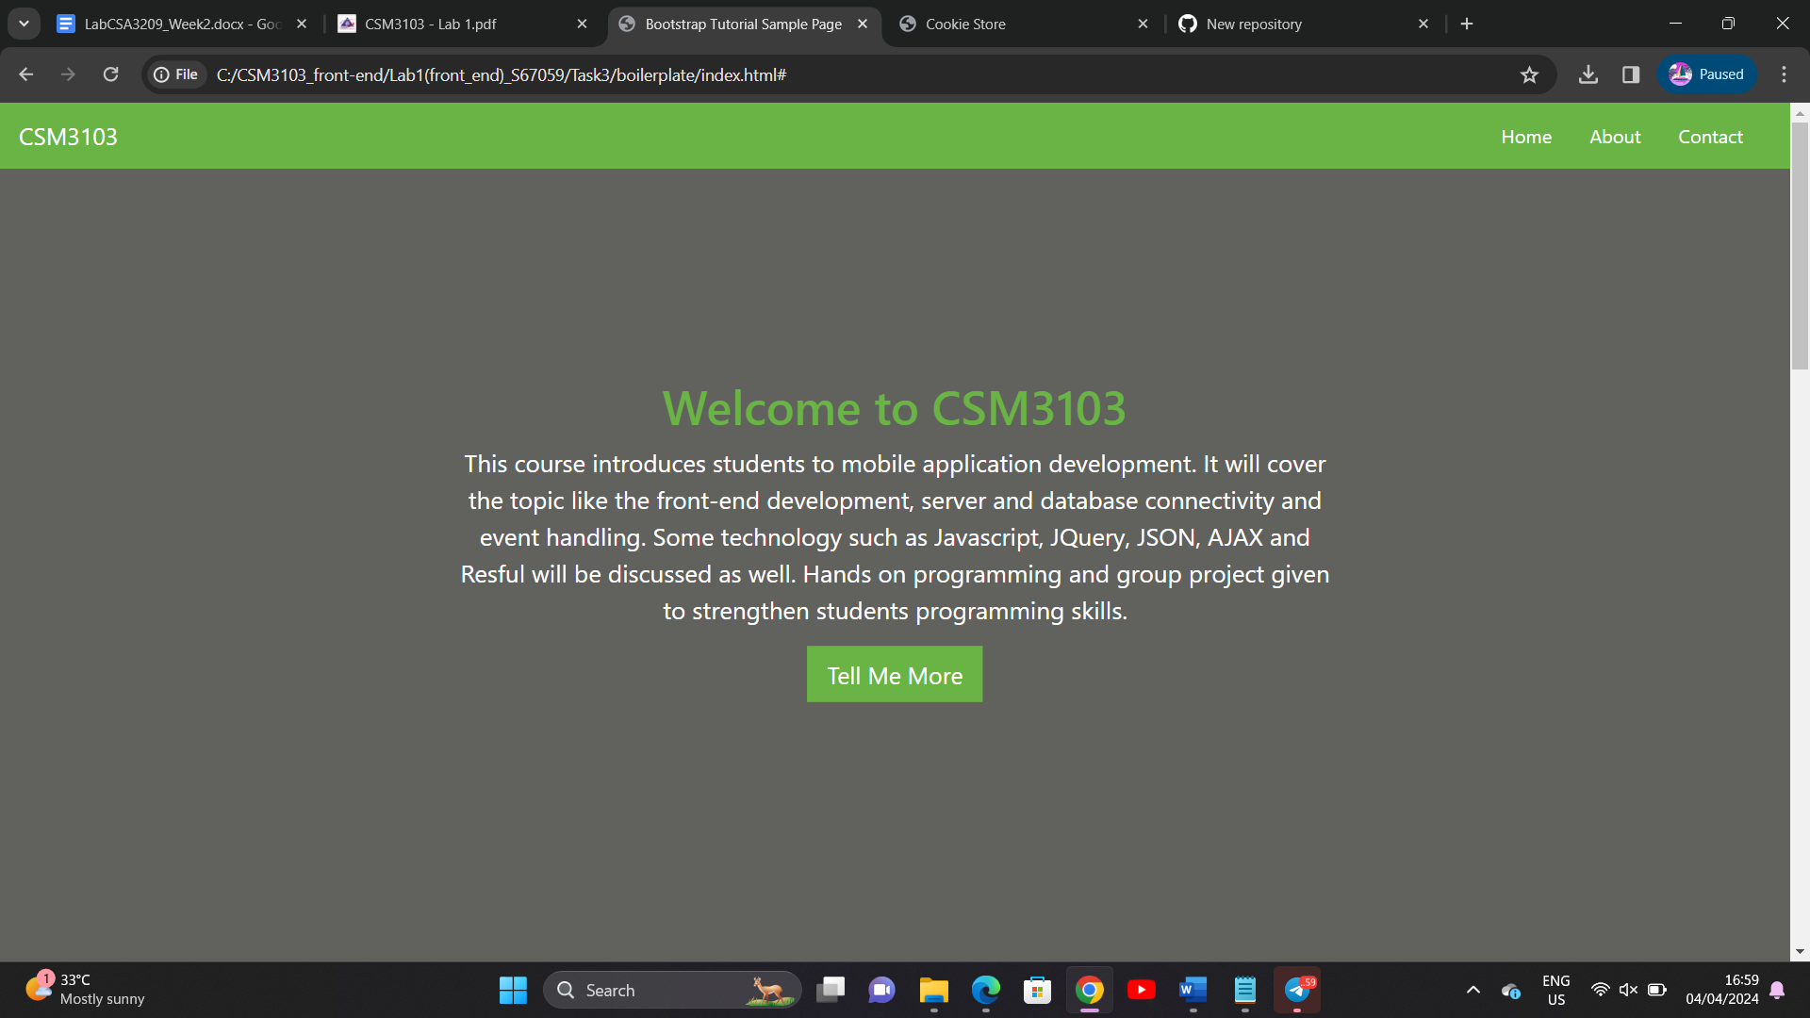

Task 4

Link Github

1. https://github.com/users/Ahmadnurbazli9/projects/2/views/1?pane=issue&itemId=58652026